**GITAM Website**

1. **Data Analysis**
   1. **Agenda for the Application:**

The following website gives the view of MEGHANA TRAVELS WEBPORTAL. This website can be used for many purposes like:

* Login into the MEGHANA TRAVELS
* Register or create an account MEGHANA TRAVELS
* Get information about MEGHANA TRAVELS
* Get the contact details of MEGHANA TRAVELS
  1. **Data to be captured:**
     + Name
     + Email id
     + Password
     + Age
     + Gender
     + Phone number

1. **Requirement Specification Documents**
   1. **Software Requirements Specification Documents**
      * **UML Diagram:**

**Class Diagram:**

The **class diagram** is the main building block of object-oriented modeling. It is used for general conceptual modeling of the structure of the application, and for detailed modeling translating the models into programming code. **Class diagrams** can also be used for data modeling

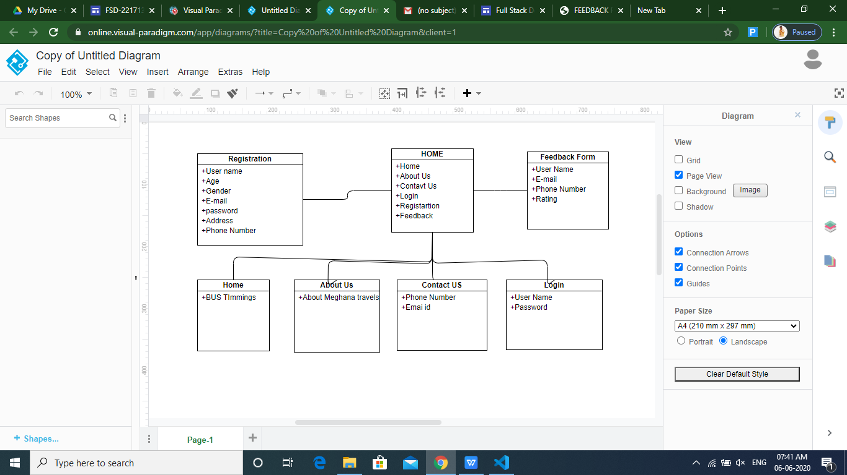

* **Classes in above diagram are:**

1. **Home**
2. **Login**
3. **Registration**
4. **About Us**
5. **Contact Us**
6. **Feedback form**
   1. **Functional Requirements Specification Documents**
   * **Wire Frames:**

A wireframe is a schematic or blueprint that is useful for helping the programmers and designers to think and communicate about the structure of the software or website you are building.

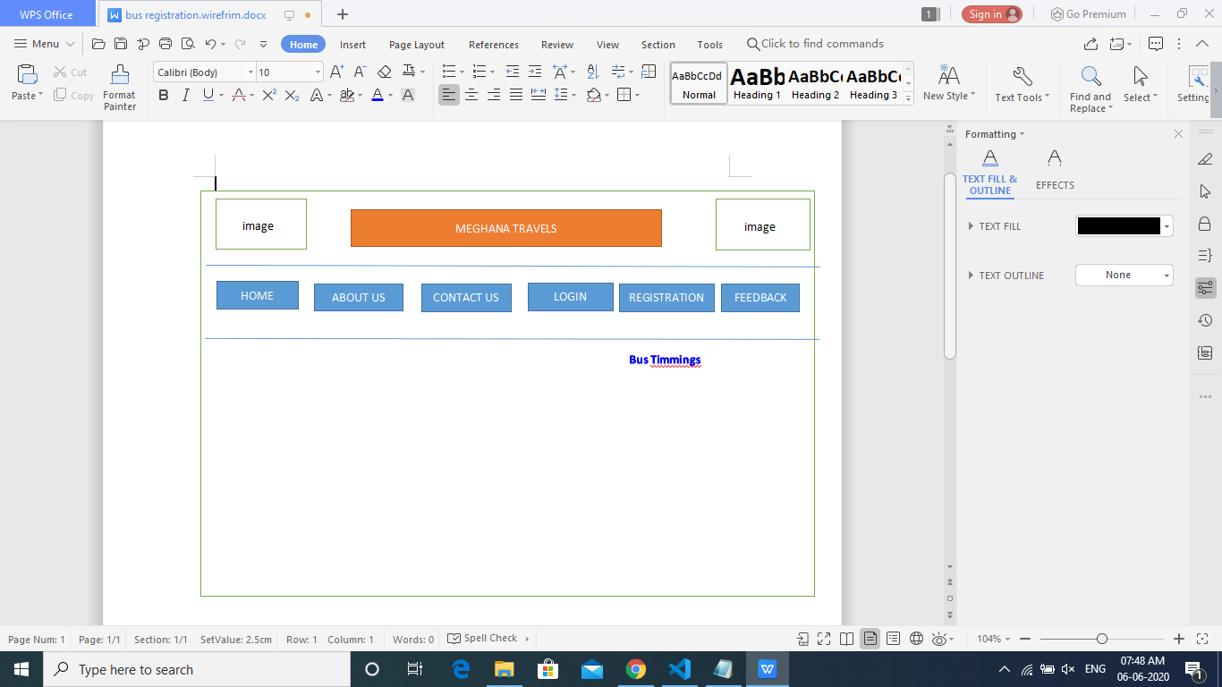

The following wireframe is the homepage of MEGHANA TRAVELS website. It has subpages such as HOME, LOGIN, REGISTRATION, ABOUT US, and CONTACT US,FEEDBACK FORM.

**Project Example:**

**HOME Page:**

This is the Home Page of MEGHANA TRAVELS, containing various subpages like LOGIN, REGISTRATION, ABOUT US, and CONTACT US,FEEDBACK FORM.

**1.LOGIN FORM**

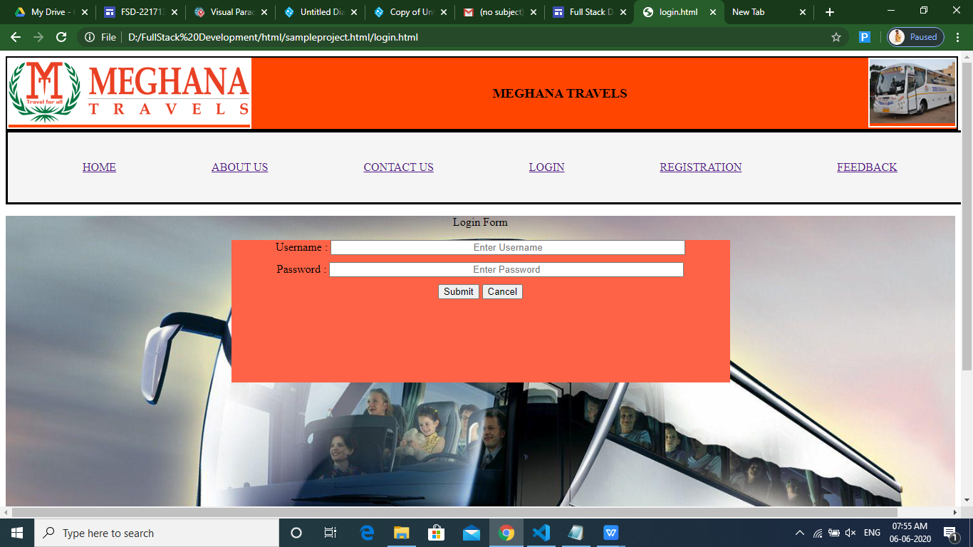

This is the LOGIN page of MEGHANA TRAVELS. Here the user has to specify his/her Username and Password.

**REGISTARTION Page:**

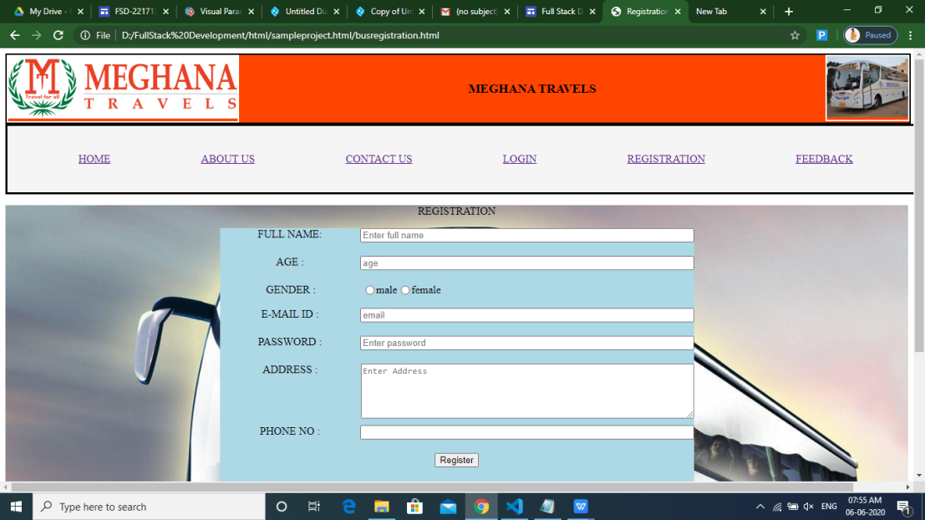

In this page the user can register for MEGHANA TRAVELS.

**ABOUT US Page:**

In this page you can get information about MEGHANA TRAVELS

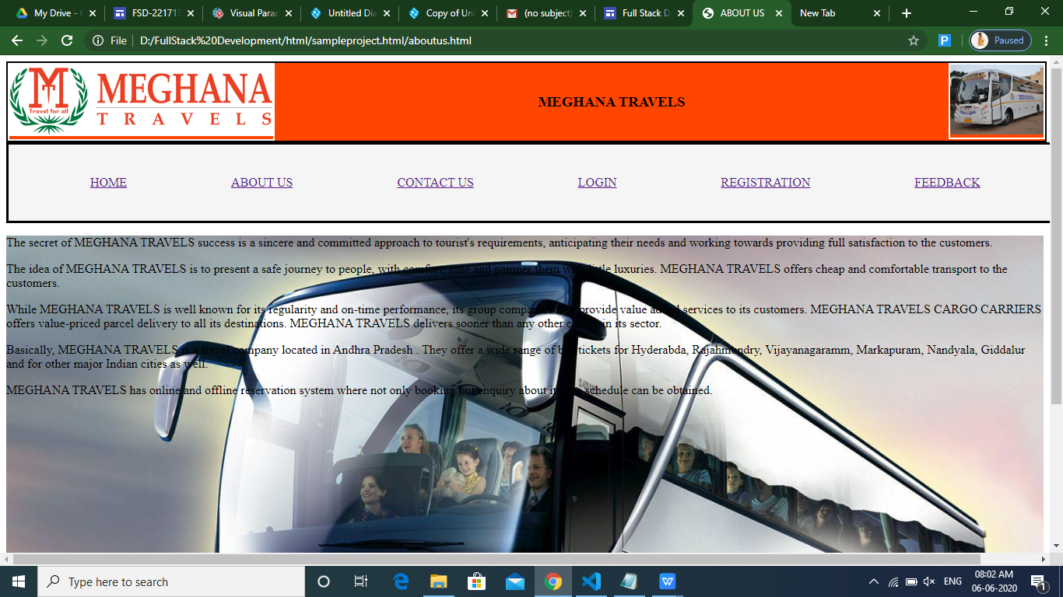

**CONTACT US Page:**

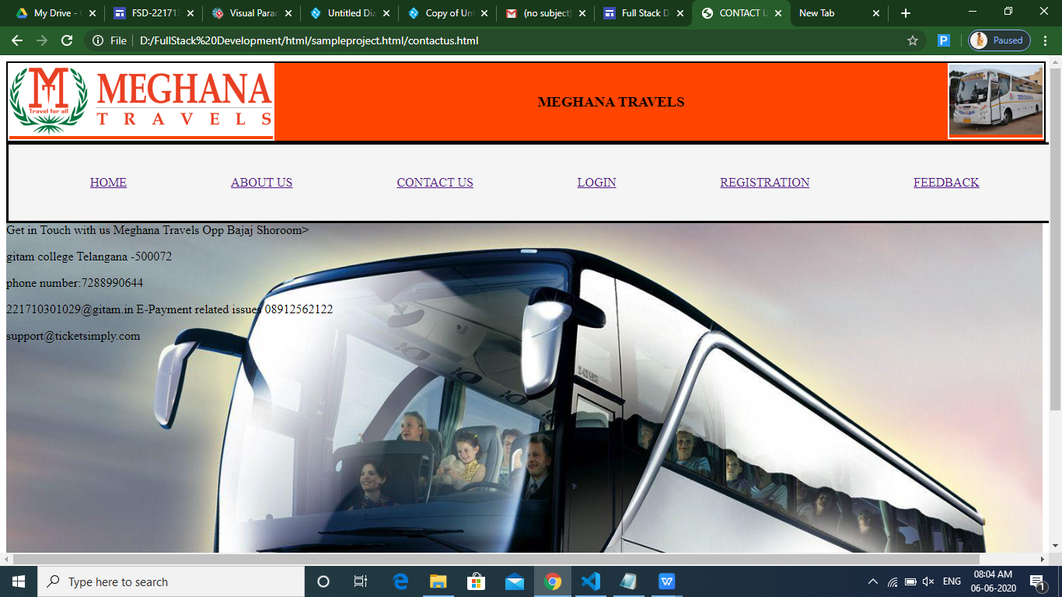

In this page one can get the contact details of MEGHANA TRAVELS